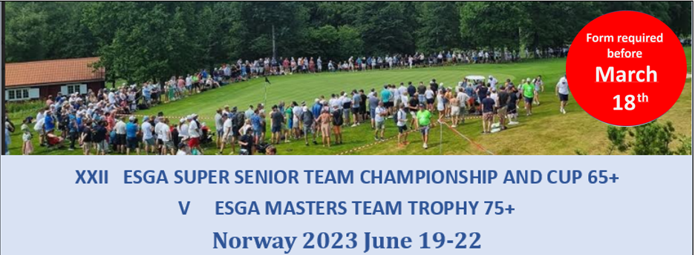
Registration form 5_S (All fee’s in NOK)

Hotel booking – Scandic Park Sandefjord
Contact information
Country
Contact person
E-mail
Telephone

Rooms
Category | Fee p.p. | Number | Arrival (date) | Departure (date)
Single room - standard | 1.090
Double room - standard | 1.290
Upgrade superior room | 200

Paying information
Mark alternative with X
 | Send me an invoice |  | Common bill |  | All rooms will be paid separately
Comments and/or invoice address:

Other remarks

 | 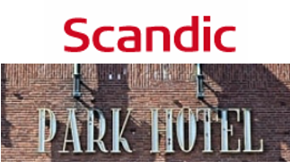 | 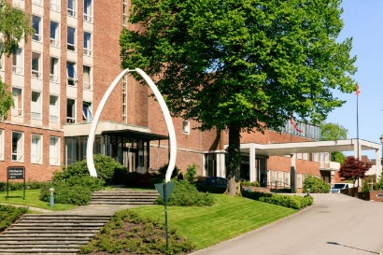

Please email this form to meeting@scandichotels.com before March 18.

