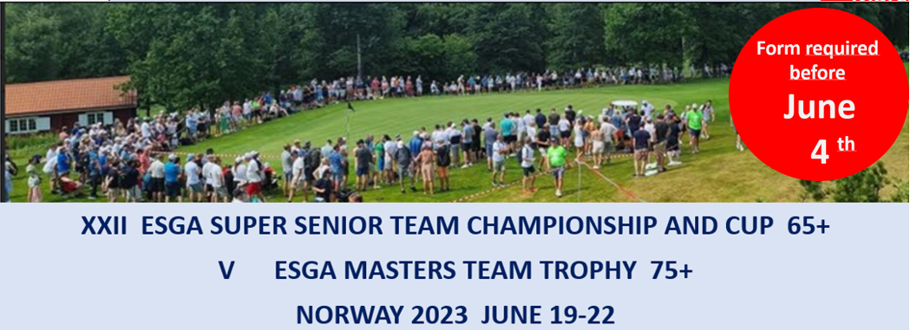
Registration form 3:

Registration non-playing participants
Country
Contact person
E-mail
Telephone
Non-playing participants
Last name | First name

Please email this form to anne-live@seniorgolf.no before June 4.

