info@agisgolf.com
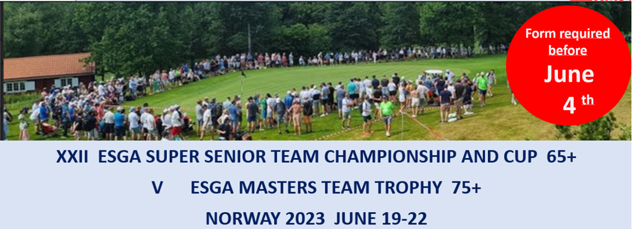
Registration form 2:

Registration of players
Country
Contact person
E-mail
Telephone

Team Super Seniors Championship included pairings in Four-Ball
Pairings | Last name | First name |  |  | HCP |  | Date of birth |  | Bus *
1
2
3
Captain: |  |  | Phone: |  |  | Mail:

Team Super Seniors Cup included pairings in Four-Ball
Pairings | Last name |  | First name |  |  | HCP |  | Date of birth |  | Bus *
1
2
3
Captain: |  |  |  | Phone: |  |  | Mail:

Team Masters Trophy included pairings in Four-Ball
Pairings | Last name |  | First name |  |  | HCP |  | Date of birth |  | Bus * | Buggy **
1
2
Captain: |  |  |  | Phone: |  |  | Mail:
The names and the pairings can be changed until the team registration (on arrival day)
Please email this form to anne-live@seniorgolf.no before June 4.
* Mark with X for players that have ordered bus ticket. If all players in the team have ordered bus ticket on Form 1_Players …. , marking is not necessary.
** For teams that have ordered a buggy (only 1 buggy for each team). Mark with an X for the players in a pair that will use the buggy. We will use these forms to combine flights on the final day to optimize the use of buggies. In that way most of the marked players can share a buggy with a player from another team. Hopefully that will be an accepted practice.

Important
It is important that the email address of the team captain is clearly written because we will use mail to inform the captains in addition to the information board in the NSG desk in the hotel. We hope that most of you can use the word-version of form 2.

