Registration form 2.

Hotel Laxnes booking. (All fee’s in ÍSL kr.)
ESGA GOLF 2024
Contact information’s.
Country
Contact person
E-mail
Telephone

HOTEL LAXNES
Room with Breakfast, free Wi-Fi and taxes | Room p.n. | Number | Arrival | Departure
Double room – Twin room | 30.000

Paying information
Each country is responsible for payments to hotels
Booking, before Nov 15th. 2023 | Deposit May 1.th 2024
Final payment by | Four weeks before arrival

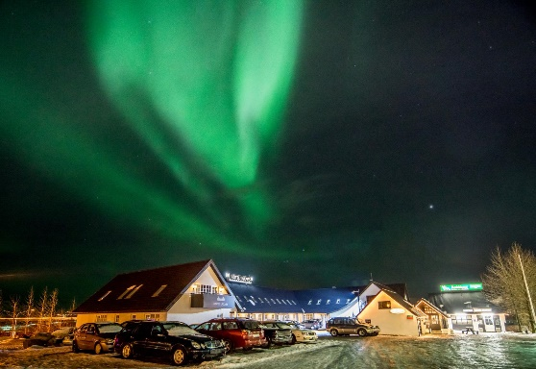 |  | 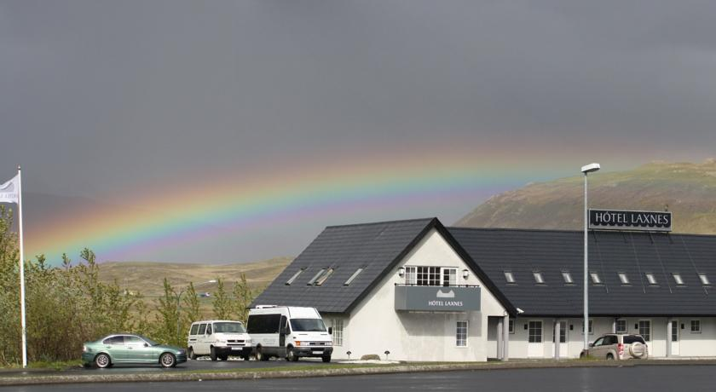

Please email this form to hotellaxnes@hotellaxnes.is before Nov. 15th. 2023
Please send a Copy to LEK@golf.is

MAPS

