Registration form 2.1

KEA-Hotels booking. (All fee’s in ÍSL kr.)
ESGA GOLF 2024

Contact information’s.
Country
Contact person
E-mail
Telephone

REYKJAVÍK LIGHTS HOTEL (32 rooms)
Room with Breakfast | Fee room p.n. | Number | Arrival (date) | Departure (date)
Single room - one bed | 26.800
Double room – double bed | 38.600
Double room – Superior | 39.200
Triple Room - Standard | 43.500

STORM HOTEL (38 rooms)
Room with Breakfast | Fee room p.n. | Number | Arrival (date) | Departure (date)
Single room - one bed | 31.700
Double room – double bed | 35.400
Double room with Balcony | 38.900

SAND HOTEL (15 rooms)
Room with Breakfast | Fee room p.n. | Number | Arrival (date) | Departure (date)
Double room – double bed | 48.500
Double room – Superior | 53.400

HOTEL BORG (10 rooms)
Room, without breakfast | Fee room p.n. | Number | Arrival (date) | Departure (date)
Double room – Standard | 55.500

Paying information
Each country is responsible for payments to hotels
Booking, before Nov 15th. 2023 | 10%, ask the Hotel about cancelation terms

Please email this form to saels@keahotels.is before Nov. 15th. 2023

Please send copy to LEK@golf.is
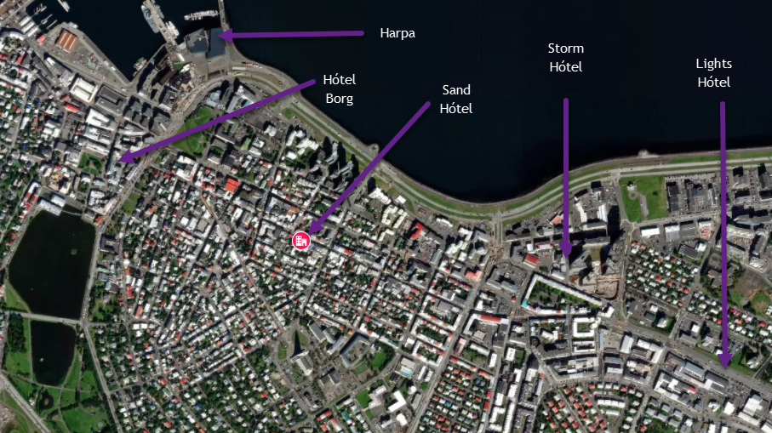
KEAHOTELS.is

Storm Hótel Reykjavík Lights Hotel
Þórunnartúni 4, 105 Reykjavík Suðurlandsbraut 12, 108 Reykjavík
Phone +354 5183000 Phone +354 5139000
Sand Hotel Hótel Borg
Laugavegur 34, 101 Pósthússtræti 11, 101
Phone +354 5198090 +354 5511440

MAPS