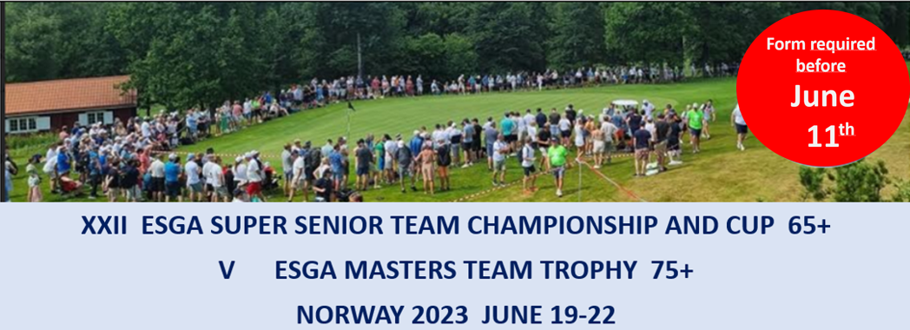
Registration form 1_Transport – Scandic Park hotel – Golf Courses
Non-playing participants – bus ticket

Country
Contact person
E-mail

This form can be used to order one day bus tickets for non-playing participants. We will confirm transport booking if there are available capacity. Book early if you need transport

 |  |  | Persons per day
To Course | Departure * | Price ** | Day 1 | Day 2 | Day 3 | Day 4
Borre GC |  | 200
Sandefjord GC |  | 150
Vestfold GC |  | 200
* Preferred departure time
** Price pr day in NOK
Comment:

 | Paying after confirmed booking | Bank: BIEN. Holder: Norsk Seniorgolf  IBAN: NO3217202723551  BIC: BIENNOK1XXX
Please email this form to anne-live@seniorgolf.no or helge@wangenconsult before June 11.

