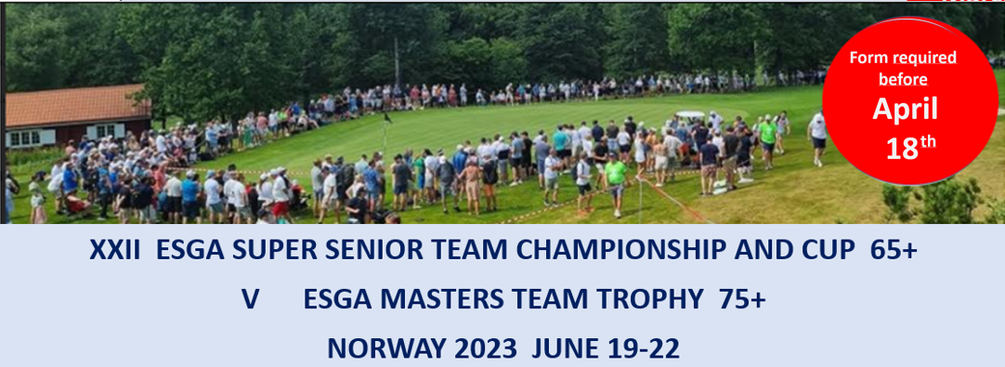
Registration form 1_Buggies

Buggies will only be available for players in Masters 75+
Country
Contact person
E-mail

ESGA rules Article 16: Buggies
Buggies, or whatever can carry a player, are permitted on condition that they can be equally distributed among all teams

General offer to all teams in Masters
1 buggy for 4 days: 200 Euro (mark below)
We order 1 buggy We do not need a buggy.

Optional (for teams that order a buggy)
If some teams want to rent two buggies, and we enough buggies to all teams that want two buggies, this will an option.
2 buggies for 4 days: 400 Euro (mark below)
We want 2 buggies We do not need 2 buggies.

 | Paying of main fee’s before  May 18. | Bank: BIEN. Holder: Norsk Seniorgolf  IBAN: NO3217202723551  BIC: BIENNOK1XXX
Please email this form to anne-live@seniorgolf.no before April 18.

