Registration form 5 (All fee’s in EURO)

Hotel booking – FOCUS HOTEL
Contact information
Country
Contact person
E-mail
Telephone

Rooms
Category | Fee per room | Number | Arrival (date) | Departure (date)
Single room - standard | 110
Double room - standard | 145
THE ROOM PRICE APPLIES ONLY TO THE DURATION OF THE TOURNAMENT

Paying information
Mark alternative with X
 | Send us an invoice |  | We pay to the bank account below
Send us the invoice to the following address:

Other remarks
In case of resignation 30 days before the start of the Tournament, 100% money back.

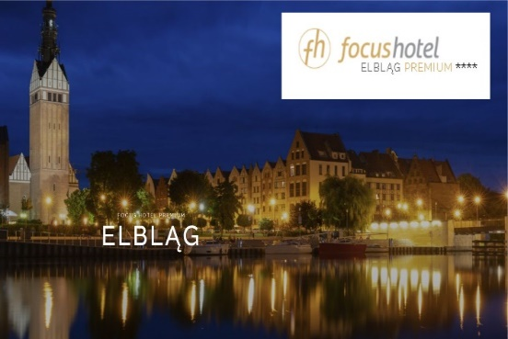 | Sand Valley Company Sp. z o.o.  Rzeczna, ul. Sand Valley 23, 14-400 Pasłęk  IBAN PL 96 1440 1039 0000 0000 0602 0607  SWIFT BPKOPLPW

Please email this form to paul.oconnor@sandvalley.pl (copy to: bbil1@o2.pl)
before February 15th, 2024.
Full payment before February 29th, 2024.

