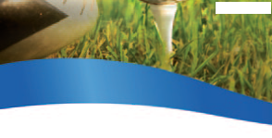
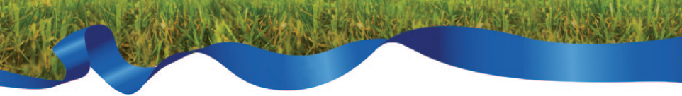
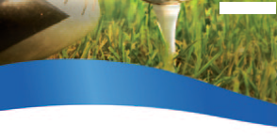
XL ESGA Seniors Team Championship & Cup 2023 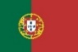

26June to 1st July 2023 Óbidos PORTUGAL

Registration FORM 2:

BOOKING FORM to the OFFICIAL HOTELS
Form required until
15th March

Nation ________________________________________

Contact Person
E-Mail
Telephone

We would like to make our Hotel Booking as follows:
Special Package Price for nights between 26th June to 1st July

 | Total rooms | Number of nigths | Price per room/night | Total amount | Room Type | Dates
Royal Óbidos SPA Hotel Single |  |  | 138 € |  |  | From  To
Royal Óbidos SPA Hotel Double |  |  | 158 € |  | Double Bed  Twin Bed | From  To
Royal Óbidos SPA Residences Single |  |  | 110 € |  |  | From  To
Royal Óbidos SPA Residences Double |  |  | 136 € |  | Double Bed  Twin Bed | From  To
MH Hotel Atlantico Golf Single |  |  | 110 € |  |  | From  To
MH Hotel Atlantico Golf Double |  |  | 136 € |  | Double Bed  Twin Bed | From  To
TOTAL SUM

EXTRA NIGTHS – BOOKINGS DATES
 | Total rooms | Number of nigths | Price per room/night | Total amount | Room Type | Dates
Royal Óbidos SPA Hotel Single |  |  | 155 € |  |  | From  To
Royal Óbidos SPA Hotel Double |  |  | 170 € |  | Double Bed  Twin Bed | From  To
Royal Óbidos SPA Residences Single |  |  | 144 € |  |  | From  To
Royal Óbidos SPA Residences Double |  |  | 156 € |  | Double Bed  Twin Bed | From  To
MH Hotel Atlantico Golf Single |  |  | 144 € |  |  | From  To
MH Hotel Atlantico Golf Double |  |  | 156 € |  | Double Bed  Twin Bed | From  To
TOTAL SUM

Date and Signature

Please send this form before 15th March 2023 to:
ANSG, Andreia Rebelo & Cristina Madaleno | E-mail: ansgolfe@gmail.com
Phone: +351 21 924 46 05 / 916 588 872
Payment of Hotel Booking is required before 15th April 2023 to the following account:
Bank: EUROBIC | IBAN: PT50 007900006491140810328 | SWIFT: BPNPPTPL

