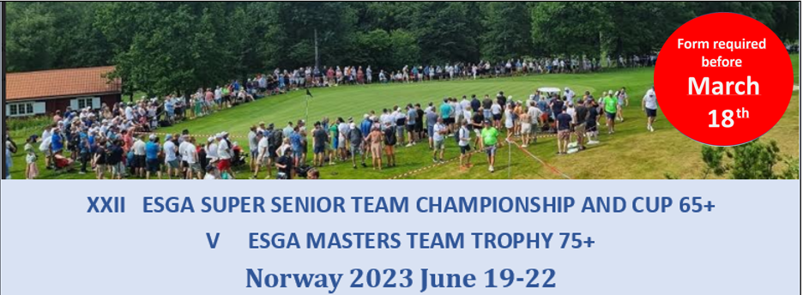
Registration form 5_A (All fee’s in NOK)

Hotel booking – Clarion Collection Hotel Atlantic
Contact information
Country
Contact person
E-mail
Telephone

Rooms
Category | Fee p.p. | Number | Arrival (date) | Departure (date)
Single room - one bed | 1.490
Single room – double bed | 1.590
Double room – double bed | 1.790
Double room – twin beds | 1.790

Paying information
Mark alternative with X
 | Send me an invoice |  | Common bill |  | All rooms will be paid separately
Comments and/or invoice address:

Other remarks

 | 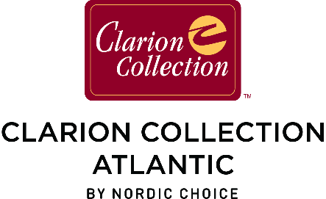 | 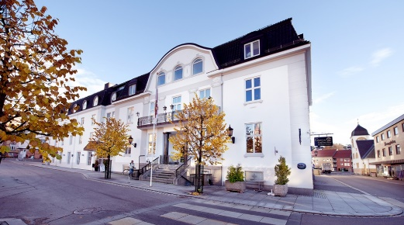

Please email this form to cc.atlantic@choice.no before March 18.

