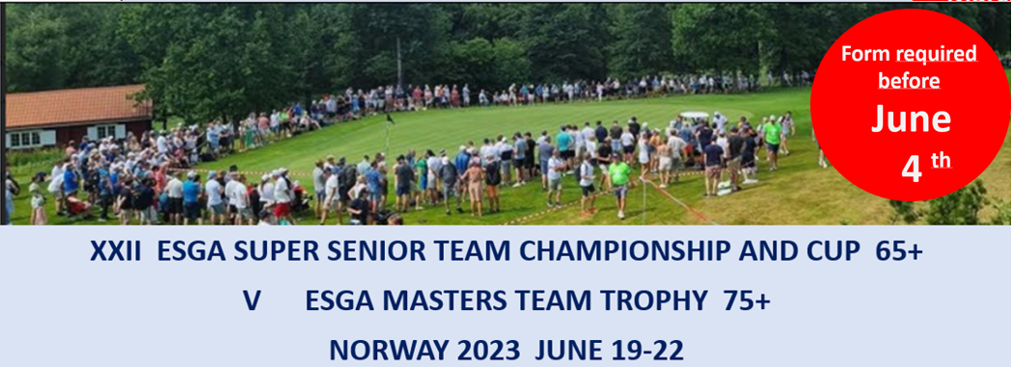Registration form 4:

Handicap certificate of the players

Country:

Team Super Seniors Championship
Players Name |  | Exact Hcp | Home club
Date: | Captains signature

Team Super Seniors Cup
Date: | Captains signature

Team Masters Trophy
Players Name |  | Exact Hcp | Home club
Date: | Captains signature
Please email this form to anne-live@seniorgolf.no before June 4.
The form must be updated and signed before the captains meeting.

