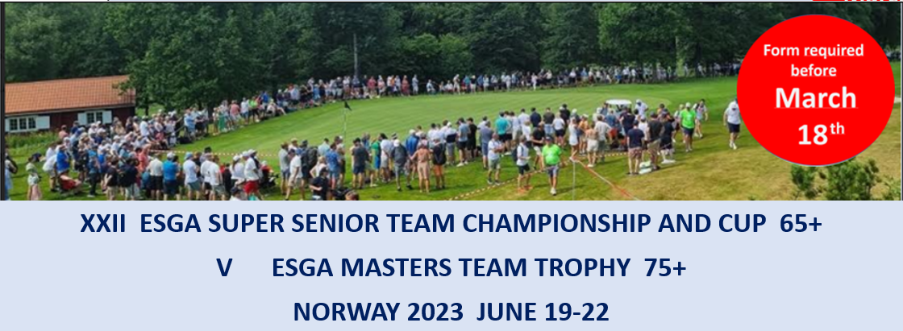
Registration form 1 (All fee’s in NOK)

Players and non-playing participants
Country
Contact person
E-mail
Telephone

Numbers of players
Event | Fee p.p. | Number | Team fee
Players in Super Seniors Teams Championship | 4.300
Players in Super Seniors Team Cup | 4.300
Players in Masters Team Trophy | 4.300
Total

Numbers of non-playing participants
 | Fee p.p. | Number | Total fee
Non-playing participants | 1.600

Trolleys
Number of: | Hand trolleys | Comment
Super Seniors Champ
Super Seniors Cup
Masters

Transportation service
We want transport from airport: | If yes mark airport | Gardermoen | Torp

Transport to/from | Fee p.p. | Number | Total fee
Scandic – Borre GK (Super Seniors Championship) | 600
Scandic – Sandefjord GK (Super Seniors Cup) | 500
Scandic – Vestfold GK (Masters) | 600

 | Paying of main fee’s before  April 18. | Bank: BIEN. Holder: Norsk Seniorgolf  IBAN: NO3217202723551  BIC: BIENNOK1XXX
Please email this form to anne-live@seniorgolf.no before March 18.

